Protein Name | Expression Host
Nectin-3 | HEK293T
Alternate Name(s) | Purity
poliovirus receptor-related 3, PVRL3, cluster of differentiation 113, CD113, nectin3, CDW113, PPR3, PRR3, PVRR3, nectin cell adhesion molecule 3 | Greater than 90% dimer form as determined by SDS-PAGE under non-reducing condition
Protein Construct | Amino Acid Range
Nectin-3 dimer protein contains a Nectin-3 extracellular domain (UniProt# Q9NQS3) fused with a proprietary cis-dimer motif followed by a tandem His-Avi tag at the C-terminus. Expressed in HEK293T cell line. | 1: G58-T404
SDS-Page Molecular Weight | Formulation
96 kDa. The migration range of the heterodimer protein with glycosylation under non-reducing condition is ~190 kDa on SDS PAGE. | 0.22μm filtered PBS, pH 7.4
Shipping Conditions | Stability & Storage
Frozen Dry Ice | -80⁰C
SDS-PAGE
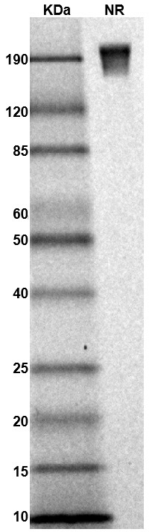
MW: Molecular Weight marker reduced condition
NR: Nectin-3 dimer under non-reduced condition

The migration range of the heterodimer protein with glycosylation under non-reducing condition is ~190 kDa on SDS PAGE.

Bioactivity – Antibody Binding | Bioactivity – Ligand Binding
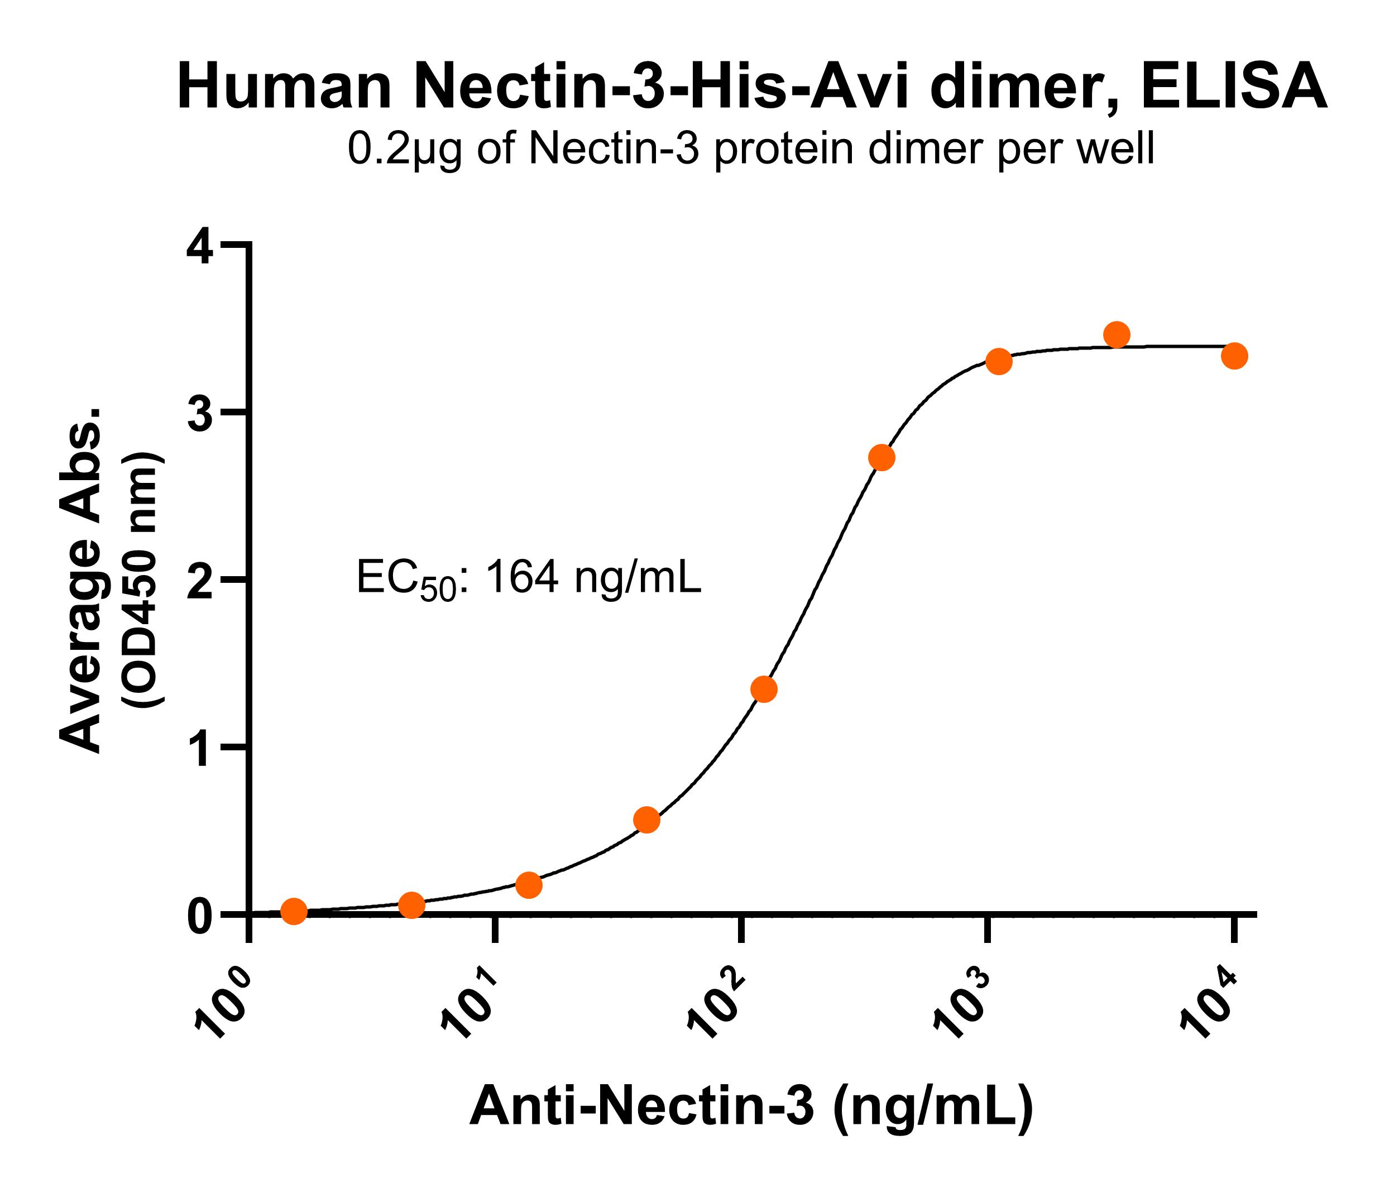 | ~i:143:200~
Immobilized human Nectin-3 protein dimer, His-Avi tag (Cat. No. CSP-25196-03) at 2 μg/mL (100 μL/well) can bind anti-human Nectin-3 monoclonal antibody with half maximal effective concentration (EC50) range of 82-327.8 ng/mL (QC tested).
Bioactivity – SPR
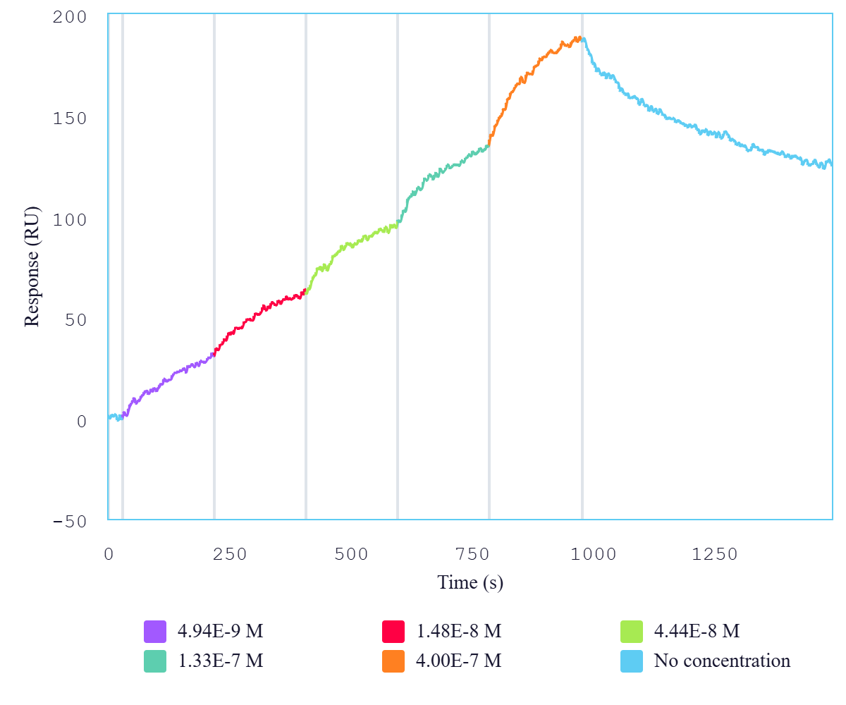
Immobilized human Nectin-1 protein dimer, His-Avi tag (Cat. No. CSP-25195-03) can bind human Nectin-3 protein dimer, His-Avi tag (Cat. No. CSP-25196-03) with a KD of 3-11.8 nM as determined by LSPR (Nicoya Alto).

Background
Human Nectin-3 is a type 1 integral membrane glycoprotein that can form a homo-cis dimer on the cell membrane. Nectin-3 is also known as poliovirus receptor-related 3 (PVRL3) and cluster of differentiation 113 (CD113). Nectin-3 contains an extracellular domain with three immunoglobulin-like (Ig-like) domains. Nectin-3 interacts with Nectin-1. Nectin-1 and Nectin-3 are expressed in neuronal tissue and unlike many other cellular adhesion molecules, they do not distribute evenly. Nectin-3 is primarily found on the dendritic side and Nectin-1 is primarily found on the axonal side. The interaction of Nectin-1 with Nectin-3 has been found to be essential for proper morphogenesis of the eye. Additionally, Nectin-3 is highly expressed in epithelial cancer cells of 80% of patients with human lung adenocarcinoma. Therefore, a recombinant protein mimicking the Nectin-3 dimer conformation can be crucial for cancer therapeutic discovery.

